PUZZLES OF OPENING OF A FILE, RANK, OR DIAGONAL

1. White mates/ Black mates
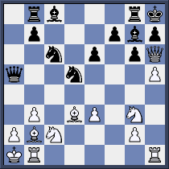

W:

B:

2. White mates/ Black wins
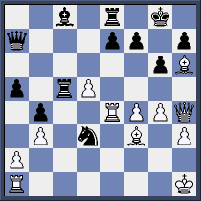

W:

B:

3. White mates/ Black mates
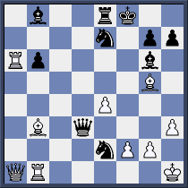

W:

B:

4. White mates/ Black to mates
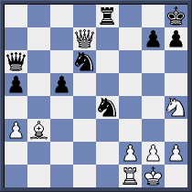

W:

B:

5. White mates/ Black mates
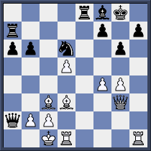

W:

B:

6. White mates/ Black wins
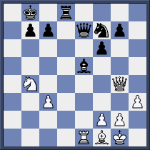

W:

B:

